Halloween Safety

Opening song: Quickly I’ll Obey (CS 197)

Opening Prayer:

Scripture: Alma 57:21

Lesson: Tell “Ghost” story as follows: (Tape ghosts on wall or large display area while telling story.)
One Halloween, in the dark of night, six little ghosts “booed” in fright. This family of ghosts had the Halloween spirit; they learned the “Halloween safety rules” and practiced them all year. Now all six were excited because the night they practiced for would soon be here. What were the safety rules? They all said together, “We’ll practice them tonight no matter what the weather!” (Show white ghosts 1-6 as you say each rule.)
Rule #1 Go with a friend, someone who stays with you until the very end.
Rule #2 Never talk to a stranger; you’ll never know just what is the danger.
Rule #3 With this rule I can’t be more graphic, when you go trick or treating, watch the traffic.
Rule #4 Go trick or treating like a pro, only go to the houses of people you know.
Rule #5 Be at your ease, don’t forget your manners – thank you and please.
Rule #6 Is a rule that can’t be beat. Look at your treats before you eat.
This family of ghosts was all white and bright. They stayed this color because they ate just right. Things like milk, vanilla ice cream and cottage cheese. Anything else would make them wheeze. Two things these ghosts really feared as Halloween night neared. What would happen if they forgot the rule? They knew they would feel the ridicule. And what would happen if they ate something they shouldn’t? They knew what would happen and the really just couldn’t.
Ghost #1 thought everyone was his friend and he knew rule #2 he just couldn’t bend. He mustn’t talk to strangers because he’d know a real torment, when he turned red with embarrassment! (Show red ghost)
Ghost #2 knew it would just be rude, to not use his manners would just mean he’s crude. He knew what would happen – yes, he really knew. For heaven’s sakes, he’d just turn blue. (Show blue ghost.)
Ghost #3 wanted to stay white all night, so he looked at the traffic and watched the scene, because the last thing he wanted was to turn bright green. (Show green ghost.)
Ghost #4 was on his best behavior and of that you’ll have to agree. Because he knew if he walked in traffic he would make a fine yellow Frisbee. (Show yellow ghost.)
A real loner was Ghost #5. So all evening he would have to strive to stay with the crowd. If from his friends he decided to shrink then he knew all night long he would surely be pink. (Show pink ghost).
Ghost #6 knew the rules by heart and he knew he’d do his part. But it was his diet that would make him slip, if he ate a chocolate chip cookie he’d do a double back flip. (Show chocolate chip ghost.)
But the ghosts shouldn’t have worried at all. The night soon ended and they all had a ball. They obeyed all the rules and did what they should and all the wrong goodies they bravely withstood. They all were happy and you could tell they were glad because this was the best night they ever had!!

Play the Halloween Game to practice the Rules. (You will need enough game pieces for every family member e.g. pennies. Fill little treat sacks with goodies and set at the end of the game.) You do not need dice to play the game, just pick up game card and follow directions.

Have little children take turns saying all the Halloween Safety rules in front of the family. (Help little kids!) Give everyone a Certificate for Safe Trick or Treating with their name on it after successfully saying the rules with loud applause!!

Activity: Carve Jack-o-Lanterns as a family and/or decorate house for Halloween with ghosts and spiders the kids color or cut out.

Closing Song: Dare to do Right (CS 158)

Closing Prayer:

Treats: Candy bags at end of game or cat cookies or Spooky Treats recipe
CAT COOKIES—Frost Oreo cookies with white frosting. Add M&M’s for the eyes and nose, black licorice string for the whiskers and upside down candy corns for the ears.

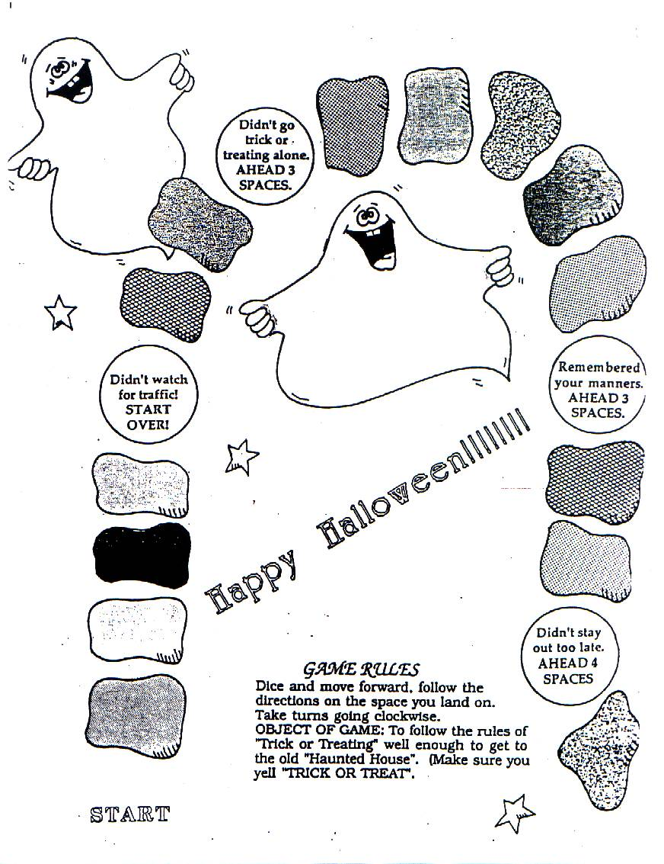
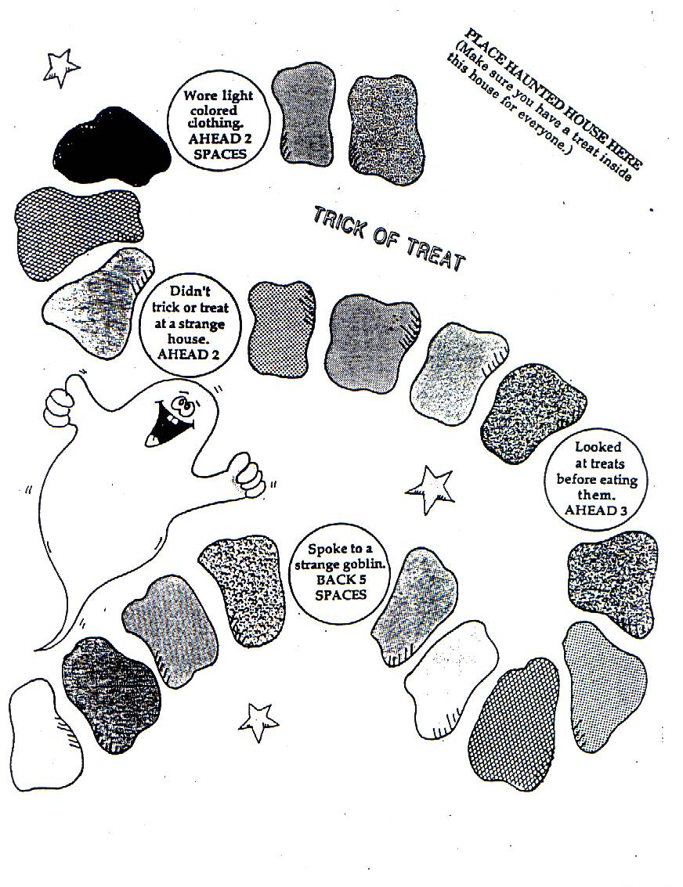
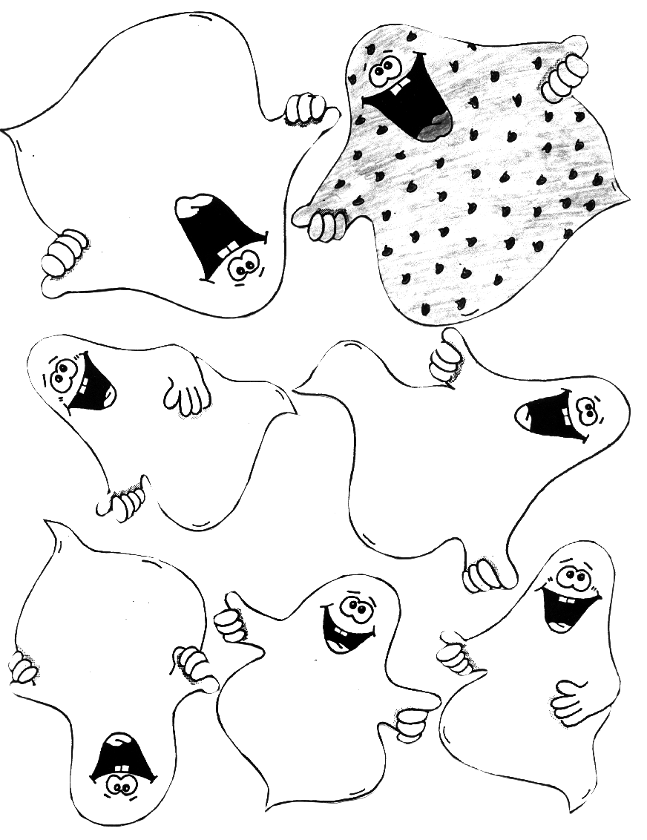
Color pink
Color green
Color blue
Color yellow
Color red
Ghost 5
Ghost 3
Ghost 2
Ghost 4
Ghost 1
Ghost 6
Chocolate chip ghost
HALLOWEEN SAFETY GAME PIECES – Copy onto cardstock and cut apart (use in place of a dice)
You talked to 2 big spooks. They grabbed your candy and ran. TOO BAD! GO BACK 1 SPACE
You said “Thank You” when given a treat. ALL RIGHT!
FORWARD 3 SPACES
You went to the same house twice. That’s not honest.
GO BACK 5 SPACES
You didn’t watch when crossing the street. OOPS!!

GO BACK 5 SPACES
You started eating treats without looking at them. OH-OH!
GO BACK 3 SPACES
You showed respect for other’s property by staying on the sidewalks. FORWARD 2 SPACES
You wore make-up instead of a mask so you could see better. GOOD! FORWARD 3 SPACES
You came home when Mom asked you to. THANKS!
FORWARD 2 SPACES
You wore light colored clothes so you could be seen. That’s great!
FORWARD 1 SPACE
You ran out in front of a car because you didn’t look. SQUISH!
GO BACK 8 SPACES
You butted in front of someone to get your treat. That’s rude!
GO BACK 3 SPACES
You came home long after you were supposed to. Mom was worried. GO BACK 7 SPACES
You left your sister behind. She was scared!
GO BACK 5 SPACES
You used your flashlight because it was a dark night. THAT’S SMART! FORWARD 4 SPACES
You didn’t say “Thank You” for your treat. That’s bad manners.
GO BACK 3 SPACES
You stayed in your area to “Trick or Treat.”
FORWARD 5 SPACES



